**Appendix C**

**SDPi Stand-alone Room - SAR**

**SDPi Silent Room Use Case - SR**

**SDPi Silent ICU Use Case - SI**

**SDPi Remote Alarm Management Use Case – RAM**

**SDPi Smart Alarm System Use Case - SAS**

Table of Contents

Overview of the 60601-1-8 Concepts for DIS, DAS and CDAS 3

SDPI- A Feature / Use Case: Silent Room (SR) Alert distribution 5

Narrative 5

Technical Pre-Conditions: 5

Rule: Single xDASmp or combination xDASmp and xDISmp/xDIScg/xDASmp 6

SR Scenario Outline 1: Detect and Communicate Alert at Bedside Device 6

SDPi-A Feature / Use Case: Silent ICU (SI) Alert Distribution 7

Narrative 7

Technical Pre-Conditions: 7

Rule: Single DAScg or combination of xDAScg and xDxSxx 7

SI Scenario Outline 1: Audible Alert at CDAScg Nurse Device 8

SDPi-A/xC Feature / Use Case: Remote Alert Management (RAM) 9

Narrative 9

Technical Pre-Conditions: 9

Rule: Single CDAScg or combination CDAScg/xDxS 9

RAS Scenario Outline 1: Adjust Alert Limit Setting at CDAScg Nurse Device 9

Annex - Overview of the 60601-1-8 Concepts for DIS, DAS and CDAS 11

DIS - * DISTRIBUTED INFORMATION SYSTEM ABOUT ALARM CONDITIONS 11

DAS - * DISTRIBUTED ALARM SYSTEM 11

CDAS - DISTRIBUTED ALARM SYSTEM WITH OPERATOR CONFIRMATION 12

# Overview of the 60601-1-8 Concepts for DIS, DAS and CDAS

The following is a quick guide to the functionality of DIS, CDIS, DAS and CDAS systems. Please refer to the Annex for relevant excerpts from 60601-1-8:2020 for normative text.

DIS – Distributed Information System

* DIS is a system for reporting alarm signals with no technical confirmation (of receipt).
  + Cannot rely on it for alarm signaling as a risk control
  + Optional support operator alarm management* response locally
  + Example - patient remote display, hallway display, one-way pager

CDIS – Distributed Information System with Confirmation

* CDIS is a system for reporting alarm signals with no technical confirmation and operator confirmation (accept/reject). (Note it is not recognized in 60601-1-8)
  + Cannot rely on it for alarm signaling as a risk control
  + Optional support operator alarm management* response locally and remotely
  + Example – two-way pager (open loop)

DAS – Distributed Alarm System

* DAS is a system for reporting alarm signals with technical confirmation (of receipt).
  + Can rely on it for alarm signaling as a risk control
  + Optionally supports local alarm management (alarm acknowledgement)
  + A communications failure or failure in any remote component of the DAS must initiate a technical alarm.
  + Example - Central Station

CDAS - Distributed Information System with Confirmation

* CDAS is a system for reporting alarm signals with technical and operator confirmation (accept/reject) (of receipt).
  + Can rely on it for alarm signaling as a risk control
  + Supports operator confirmation (accept/reject); It may redirect…
  + Optionally support local/remote alarm management (acknowledgement)
  + A communications failure or failure in any remote component of the DAS must initiate a technical alarm.
  + Example - System that sends alarm to caregiver mobile device with accept / reject. Integrator may redirect

The following table summarizes the various types of information/alarm systems.

|  |  |  |  |  |  |
| --- | --- | --- | --- | --- | --- |
| **Description** | **Type** | **Technical Delivery Confirmation1** | **Operator Delivery Confirmation2** | **Optional Alarm Management** | **Examples** |
| Reports alerts from a Single Patient (sp) | DISsp | No | No | Local | Single-Pt. information dashboard |
| CDISsp | No | Yes3 | Remote3 | Single-Pt. dashboard w/ accept/reject |
| DASsp | Yes | No | Local | Single Pt. Remote view w/audible alarms |
| CDASsp | Yes | Yes | Remote | Single Pt. Remote View w/ accept/reject |
| Reports alerts from Multiple Patients (mp) | DISmp | No | No | Local | Multiple-Pt. info. Dashboard or View Station |
| CDISmp | No | Yes3 | Remote3 | Multiple-Pt. info. View Station w/ accept/reject |
| DASmp | Yes | No | Local | Multiple Pt. Central Station w/ audible alarms |
| CDASmp | Yes | Yes | Remote | Multiple Pt. Central Station w/ accept/reject |
| Reports and directs alerts to responsible Caregiver (cg) | DIScg | No | No | Local | Alerts to caregiver pager, Mobile viewer |
| CDIScg | No | Yes3 | Remote3 | Alerts to caregiver pager, w/ accept/reject |
| DAScg | Yes | No | Local | Alerts to caregiver w/ audible/haptic alarms |
| CDAScg | Yes | Yes | Remote | Alerts to caregiver w/ accept/reject |
| 1 In each communication step the receiving device provides a technical response to the sending device that it received and is taking responsibility for the alert  2 Operator can, at their choice, use the receiving device (communicator) UI to accept or reject responsibility for the alert  3 Not recommended since there is no confirmation that the Source has received the commands | | | | | |

# SDPI- A Feature / Use Case: Silent Room (SR) Alert distribution

## Narrative

Linda is an ICU nurse responsible for 4 patients. While she is updating documentation at the nursing station Jack’s (one of her patients) condition deteriorates and his ventilator goes into an alarm state (#1). The ventilator alarm sounds are quite loud and jarring which usually disturbs the patient in the room and nearby rooms. In this case the alert only generates visual alerts and does not generate an audible tone in the patient room (#2). It does generate an alarm tone at the central station (xDASmp) (#3) and her mobile device (xDAScg) (#4). As a result, Linda must acknowledge or otherwise handle the alert at the bedside (#5).

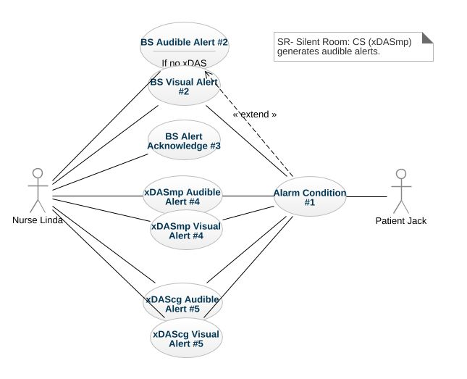

## Technical Pre-Conditions:

* Bedside devices are SDC compliant
* At least one xDASmp that is SDC compliant
* All Devices in Room delegate their alerts to one or more xDASmp.

## 

## Rule: Single xDASmp or combination xDASmp and xDISmp/xDIScg/xDASmp

Note: xDAScg is not included since this can lead to a Silent ICU scenario

## SR Scenario Outline 1: Detect and Communicate Alert at Bedside Device

### Scenario 1.1: Medical device detects an alert situation and at least one distributed alarm system xDASmp is accessible

**Given** alert event was detected by a medical device attached to the patient

**When** at least one remote alert system is accessible

**Then** the alert shall be shown on all accessible remote alerting devices

**And** the audio alarm shall be enabled on all accessible remote alerting devices

**And** active device alert events shall be shown on the medical devices locally

**And** the audio alarm shall be disabled on all medical devices in the patient room

### Scenario 1.2: Medical device detects an alert situation and all distributed alarm systems (xDASxx) are inaccessible or become inaccessible

**Given** alert event was detected by a medical device attached to the patient

**When** distributed alarm systems (DAS/DIS) are inaccessible or become inaccessible

**Then** active device alert events shall be shown on the medical devices locally

**And** the audio alarm shall be enabled on all medical devices in the patient room

### Scenario 1.3: Alert situation has been resolved and at least one distributed alarm system (xDASxx) is accessible

**Given** medical device detected that the alert situation has been resolved

**When** at least one distributed alarm system (DAS/DIS) is accessible

**Then** the alert shall be shown as inactive/ended at the medical device locally

**And** the audio alarm shall be disabled on the medical device in the patient room

**And** the alert shall be shown as inactive/ended on all accessible remote alerting devices

**And** the audio alarm shall be disabled on all accessible remote alerting device for this alert event

### Scenario 1.4: Medical device detects an alert situation, initially DAS is accessible but fails

# SDPi-A Feature / Use Case: Silent ICU (SI) Alert Distribution

## Narrative

Jackie is an ICU nurse responsible for 4 patients. While she is updating documentation at the nursing station Sven’s (one of her patients) condition deteriorates and his ventilator goes into an alarm state (#1). The ventilator alarm sounds are quite loud and jarring which usually disturbs the patient in the room and nearby rooms. Jackie’s ICU uses personal mobile devices to alert the nurses about patient alarms so in this case the alert only generates visual alerts in the patient room (#2) and central station (#3). It does generate an audible alert on her mobile device (xDAScg) (#4).

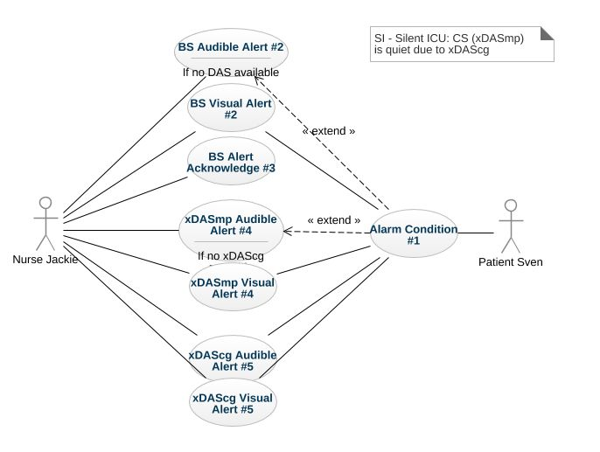

## Technical Pre-Conditions:

* Bedside devices are SDC compliant
* A DAScg that is SDC compliant
* All Devices in Room delegate their alerts to one or more DASxx or CDASxx.

## Rule: Single DAScg or combination of xDAScg and xDxSxx

## SI Scenario Outline 1: Audible Alert at CDAScg Nurse Device

### SI Scenario 1.1: Medical device detects an alert situation and the distributed alarm system CDAScg is accessible and announces the alert at the caregiver device

**Given** alert event was detected by a medical device attached to the patient

**When** at least one remote alert system is accessible

**Then** the alert shall be shown on all accessible remote alerting devices

**And** the audio alarm shall be enabled on the caregiver’s accessible CDAScg remote alerting devices

**And** the audio alarm shall be disabled on all accessible non-CDAScg remote alerting devices

**And** active device alert events shall be shown on the medical devices locally

**And** the audio alarm shall be disabled on all medical devices in the patient room

### SI Scenario 1.2: Medical device detects an alert situation and the distributed alarm system CDAScg is inaccessible

**Given** alert event was detected by a medical device attached to the patient

**When** at least one remote alert system is accessible

**Then** the alert shall be shown on all accessible remote alerting devices

**And** the audio alarm shall be enabled on all accessible remote alerting devices

**And** active device alert events shall be shown on the medical devices locally

**And** the audio alarm shall be disabled on all medical devices in the patient room

### SI Scenario 1.3: Medical device detects an alert situation and all distributed alarm systems (xDASxx) are inaccessible or become inaccessible

**Given** alert event was detected by a medical device attached to the patient

**When** distributed alarm systems (DAS/DIS) are inaccessible or become inaccessible

**Then** active device alert events shall be shown on the medical devices locally

**And** the audio alarm shall be enabled on all medical devices in the patient room

### SI Scenario 1.4: Alert situation has been resolved and at least one distributed alarm system (DASxx) is accessible

**Given** medical device detected that the alert situation has been resolved

**When** at least one distributed alarm system (DAS/DIS) is accessible

**Then** the alert shall be shown as inactive/ended at the medical device locally

**And** the audio alarm shall be disabled on the medical device in the patient room

**And** the alert shall be shown as inactive/ended on all accessible remote alerting devices

**And** the audio alarm shall be disabled on all accessible remote alerting device for this alert event

### Scenario 1.5: Medical device detects an alert situation, initially DAS is accessible but fails

# SDPi-A/xC Feature / Use Case: Remote Alert Management (RAM)

## Narrative

Boris is an ICU nurse responsible for 4 patients. His ICU has a central station but also uses personal devices for alert notification and management. He needs to adjust the upper heart rate limit for Caroline, one of his patients. Even though Boris is near the central station, he decides to use his personal device to adjust the limit (#1).

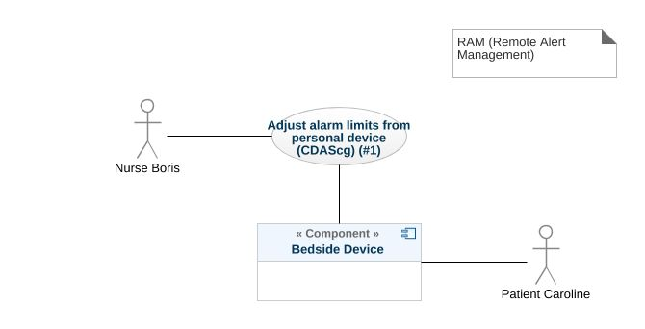

## Technical Pre-Conditions:

* Bedside devices are SDC compliant
* A CDAScg that is SDC compliant
* All Devices in Room enable remote setting adjustment

## Rule: Single CDAScg or combination CDAScg/xDxS

## RAM Scenario Outline 1: Adjust Alert Limit Setting at CDAScg Nurse Device

### RAM Scenario 1.1: Caregiver adjusts alarm limit at their Mobile Device

**Given** alert event was detected by a medical device attached to the patient

**And** remote alerting device is part of the CDAScg

**When** caregiver confirms the alert at a remote alerting device

**And** CDAScg is accessible

**Then** the alert shall be shown as acknowledged at the medical device

**And** the audio alarm shall be disabled on the medical device

**And** the alert shall be shown as acknowledged on all accessible remote alerting devices

### RAM Scenario 1.2: Caregiver attempts to adjust alarm limit at their CDAScg mobile device but the respective CDAScg is not accessible

**Given** alert event was detected by a medical device attached to the patient

**And** remote alerting device is part of the DIS

**When** caregiver confirms the alert at a remote alerting device

**But** DAS is inaccessible

**Then** ???

# Annex – References from 60601-1-8:2020 for DIS, DAS and CDAS

## DIS - * DISTRIBUTED INFORMATION SYSTEM ABOUT ALARM CONDITIONS

system that involves more than one item of equipment in a ME SYSTEM intended to provide information about ALARM CONDITIONS but does not guarantee delivery of that information

NOTE 1 A DISTRIBUTED INFORMATION SYSTEM ABOUT ALARM CONDITIONS is not intended to notify OPERATORS of the existence of an ALARM CONDITION as a RISK CONTROL measure. A DISTRIBUTED INFORMATION SYSTEM ABOUT ALARM CONDITIONS is intended to provide information about an ALARM CONDITION while the OPERATOR is aware of the existence of the ALARM CONDITION by an ALARM SYSTEM.

NOTE 2 A DISTRIBUTED INFORMATION SYSTEM ABOUT ALARM CONDITIONS is not intended for confirmed delivery of ALARM CONDITIONS

Examples could be:

Sometimes referred to as secondary alerting devices: Hallway display of active alarms; Hallway light over room door; Caregiver worn device;

## DAS - * DISTRIBUTED ALARM SYSTEM

ALARM SYSTEM that involves more than one item of equipment in a ME SYSTEM intended for delivery of ALARM CONDITIONS with technical confirmation

NOTE 1 The parts of a DISTRIBUTED ALARM SYSTEM can be widely separated in distance.

NOTE 2 A DISTRIBUTED ALARM SYSTEM is intended to notify OPERATORS of the existence of an ALARM CONDITION.

NOTE 3 For the purposes of this document, technical confirmation means that each element of a DISTRIBUTED ALARM SYSTEM confirms or guarantees the successful delivery of the ALARM CONDITION to the next element or appropriate TECHNICAL ALARM CONDITIONS are created as described in 6.11.2.2.1.

Examples could be:

Central Station without alarm accept/reject.



* EXAMPLE 1 – A central station
* EXAMPLE 2 – An electronic record-keeping device
* EXAMPLE 3 – Remote viewing from home or office
* EXAMPLE 4 – Bed-to-bed viewing of ALARM CONDITIONS (e.g. one nurse for two beds).
* EXAMPLE 5 – Transmission of ALARM CONDITIONS to pagers, cell phones, hand-held computers, etc.

## CDAS - DISTRIBUTED ALARM SYSTEM WITH OPERATOR CONFIRMATION

DISTRIBUTED ALARM SYSTEM that includes the capability to receive an OPERATOR response

Examples could be:

Traditional Central Station; Bed to Bed alarm feature supporting alarm acknowledge; Caregiver worn device supporting alarm acknowledge

### 6.11.2.4 * CDAS

In a CDAS, the COMMUNICATOR that receives an ALARM CONDITION shall have means to create the OPERATOR responses (RESPONSIBILITY ACCEPTED or RESPONSIBILITY REJECTED) and transfer them to the INTEGRATOR.

1. In a CDAS, the COMMUNICATOR that receives an ALARM CONDITION and initiates an OPERATOR response (RESPONSIBILITY ACCEPTED or RESPONSIBILITY REJECTED) shall indicate the OPERATOR response state (RESPONSIBILITY ACCEPTED or RESPONSIBILITY REJECTED).

The means of control used to initiate an OPERATOR response or indication of state may be marked with:

1. symbol ISO 7000-6334A (2015-06) (see Symbol 13 of Table C.1) for RESPONSIBILITY ACCEPTED; or
2. symbol ISO 7000-6335A (2015-06) (see Symbol 16 of Table C.1) for RESPONSIBILITY REJECTED.

Means shall be provided for the OPERATOR to terminate RESPONSIBILITY ACCEPTED or RESPONSIBILITY REJECTED while the related ALARM CONDITION is active. Initiating RESPONSIBILITY REJECTED may be used to terminate RESPONSIBILITY ACCEPTED. Initiating RESPONSIBILITY ACCEPTED may be used to terminate RESPONSIBILITY REJECTED.

In a CDAS, RESPONSIBILITY ACCEPTED may initiate an ALARM SIGNAL inactivation state.

NOTE RESPONSIBILITY ACCEPTED is a different function than an ALARM SIGNAL inactivation state.

In a CDAS, the INTEGRATOR shall have means to accept OPERATOR responses from the COMMUNICATOR.

In a CDAS, the SOURCE may receive OPERATOR responses from the INTEGRATOR.

### Subclause 6.11.2.4 – CDAS

The terms RESPONSIBILITY ACCEPTED, RESPONSIBILITY REJECTED, and RESPONSIBILITY UNDEFINED are new to this document. They are most often applicable to a DISTRIBUTED ALARM SYSTEM for use in an intensive care setting or a hospital ward setting, in which each OPERATOR has a COMMUNICATOR (example: pocket pager or phone) that provides an ALARM CONDITION to a specific OPERATOR. If the DISTRIBUTED ALARM SYSTEM presents an ALARM CONDITION to a specific OPERATOR, then there can be three possibilities:

* the specific OPERATOR accepts responsibility for the ALARM CONDITION, and the state RESPONSIBILITY ACCEPTED becomes true;
* the specific OPERATOR is busy and therefore rejects responsibility, the state RESPONSIBILITY REJECTED becomes true, and the DISTRIBUTED ALARM SYSTEM redirects the ALARM CONDITION to a different COMMUNICATOR, hence OPERATOR;
* the OPERATOR does not respond to the ALARM SIGNAL within the timeframe established by the RESPONSIBLE ORGANIZATION in the INTEGRATOR, the state RESPONSIBILITY UNDEFINED becomes true, and the INTEGRATOR redirects the ALARM CONDITION to a different COMMUNICATOR, hence OPERATOR in this instance also.

A similar configuration might be provided for other DISTRIBUTED ALARM SYSTEMS, for instance, from a bedside monitor to a different bedside monitor, or from a beside monitor to a central station.

Care is needed in the design of a CDAS when there is a non-homogenous set of SOURCES. The logic (REDIRECTION and ESCALATION) behind the processing of RESPONSIBILITY UNDEFINED can become very complex and needs to take into account how each SOURCE responds to the resulting states. These complex systems can inadvertently cause ALARM FLOOD or ‘lost’ ALARM CONDITIONS (i.e. no assigned COMMUNICATOR).

Such a configuration would not be expected in ME EQUIPMENT without a DISTRIBUTED ALARM SYSTEM. For example, an anaesthesia workstation, for which an OPERATOR is normally present during all PATIENT care, would not be expected to provide these functions.

6

Thus, in a network of bedside PATIENT monitors, one bedside PATIENT monitor can act as a COMMUNICATOR for ALARM CONDITIONS from a different bedside PATIENT monitor. A central station can act as a COMMUNICATOR for ALARM CONDITIONS from multiple PATIENTS. A two-way wireless communication system can act as a COMMUNICATOR for ALARM CONDITIONS to a caregiver in an area far removed from the PATIENT. All these are examples of DISTRIBUTED ALARM SYSTEMS.